Table design

Table 1: Staff

Table 2: Item

Table 3: Customer

Table 4: Cost

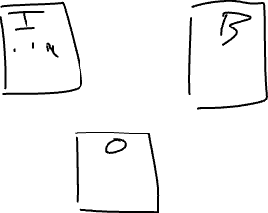

Table 5: Branch



Table 6: Order / transaction / invoice

Table 1: Item

* id int Primary key
* name varchar(100) not null
* price real (float) default = 0
* size varchar(1) check: S, M, L

Table 2: Branch

* id int PK
* location varchar(200) not null

Table 3: Order

* id varchar(5) PK
* datetime datetime not null
* item int FK (Item.id)
* branch int FK (Branch.id)
* discount real -